# Activity 1

## Why is geospatial data valuable and how can it be used?

Google Timelapse presents a video-like visualisation of images of the Earth captured by satellites from 1984 to the present day.

Head to Google Timelapse to visualise change in conditions on the Earth’s surface over time using satellite images: <https://earthengine.google.com/timelapse/>

* Search for Joondalup to visualise urban development in North Perth since 1984.
* Explore case studies in the sidebar.
* Use the search tool to explore how other locations have changed since 1984.

Consider what is driving the changes in land use and land cover that you can see. Also, consider the consequences of the change you can visualise for the environment, people, and economies.

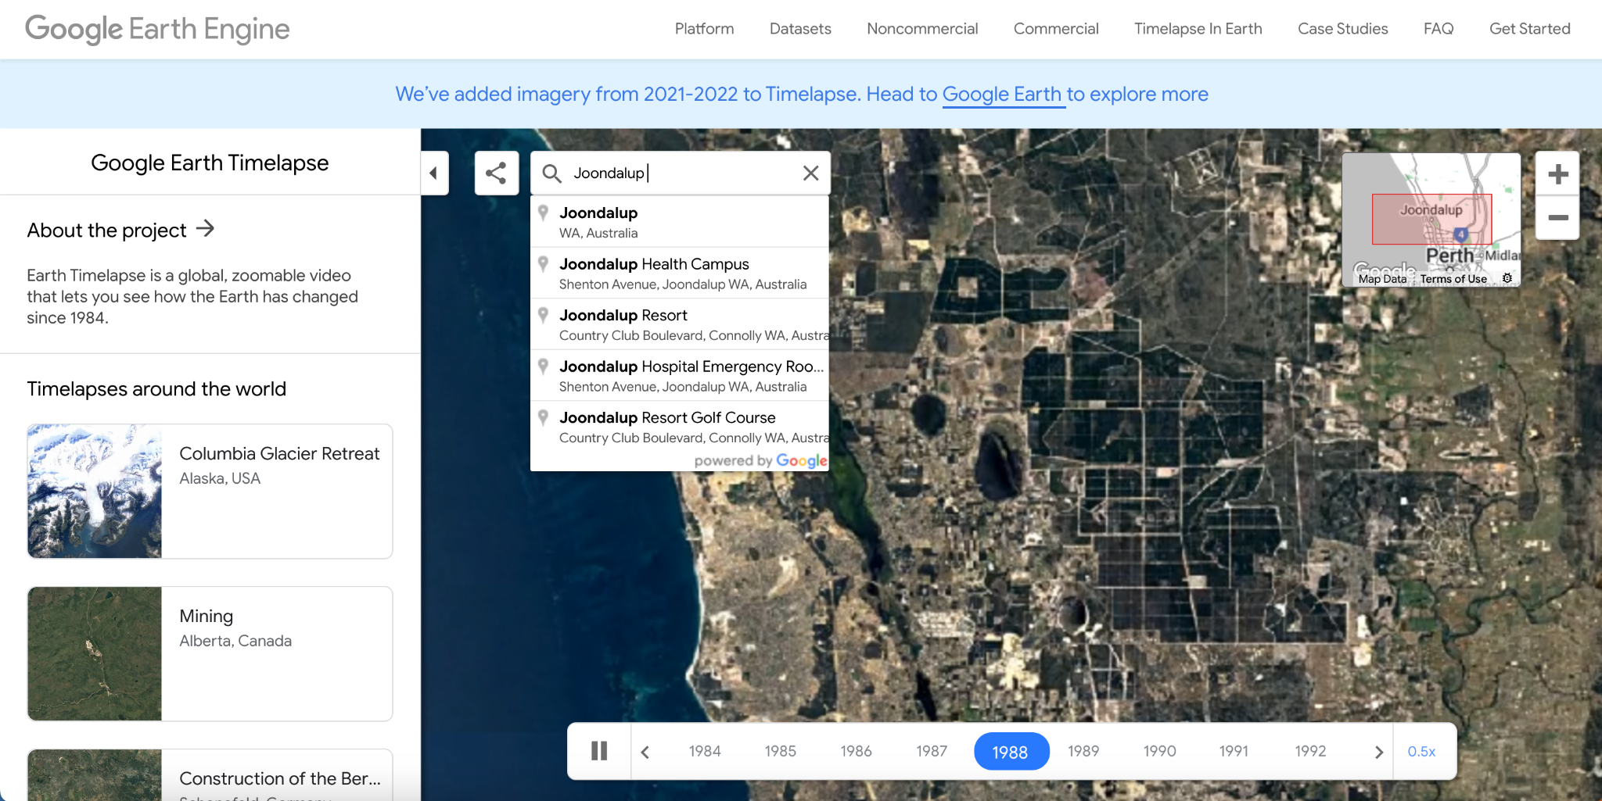

Write down ideas and suggestions that address ***why is geospatial data valuable and how can it be used?***

# Activity 2

## What is the spatial, temporal, and thematic resolution of the following geospatial datasets?

## Suggest an application or use for each dataset.

You can estimate or describe the spatial resolution of a dataset (e.g. pixel size is approximately 30 m, pixel size is less than 1 km, pixel size is small enough to detect individual trees, pixel size is sufficient for detecting broad land use / cover patterns but small objects).

### Global Surface Water Explorer: <https://global-surface-water.appspot.com/map>

**Spatial resolution:**

**Temporal resolution:**

**Thematic resolution:**

**Application:**

### 

### 

### 

### 

### 

### Water Risk Atlas: <https://www.wri.org/applications/aqueduct/water-risk-atlas>

Specifically focus on the *Riverine flood risk* layer:

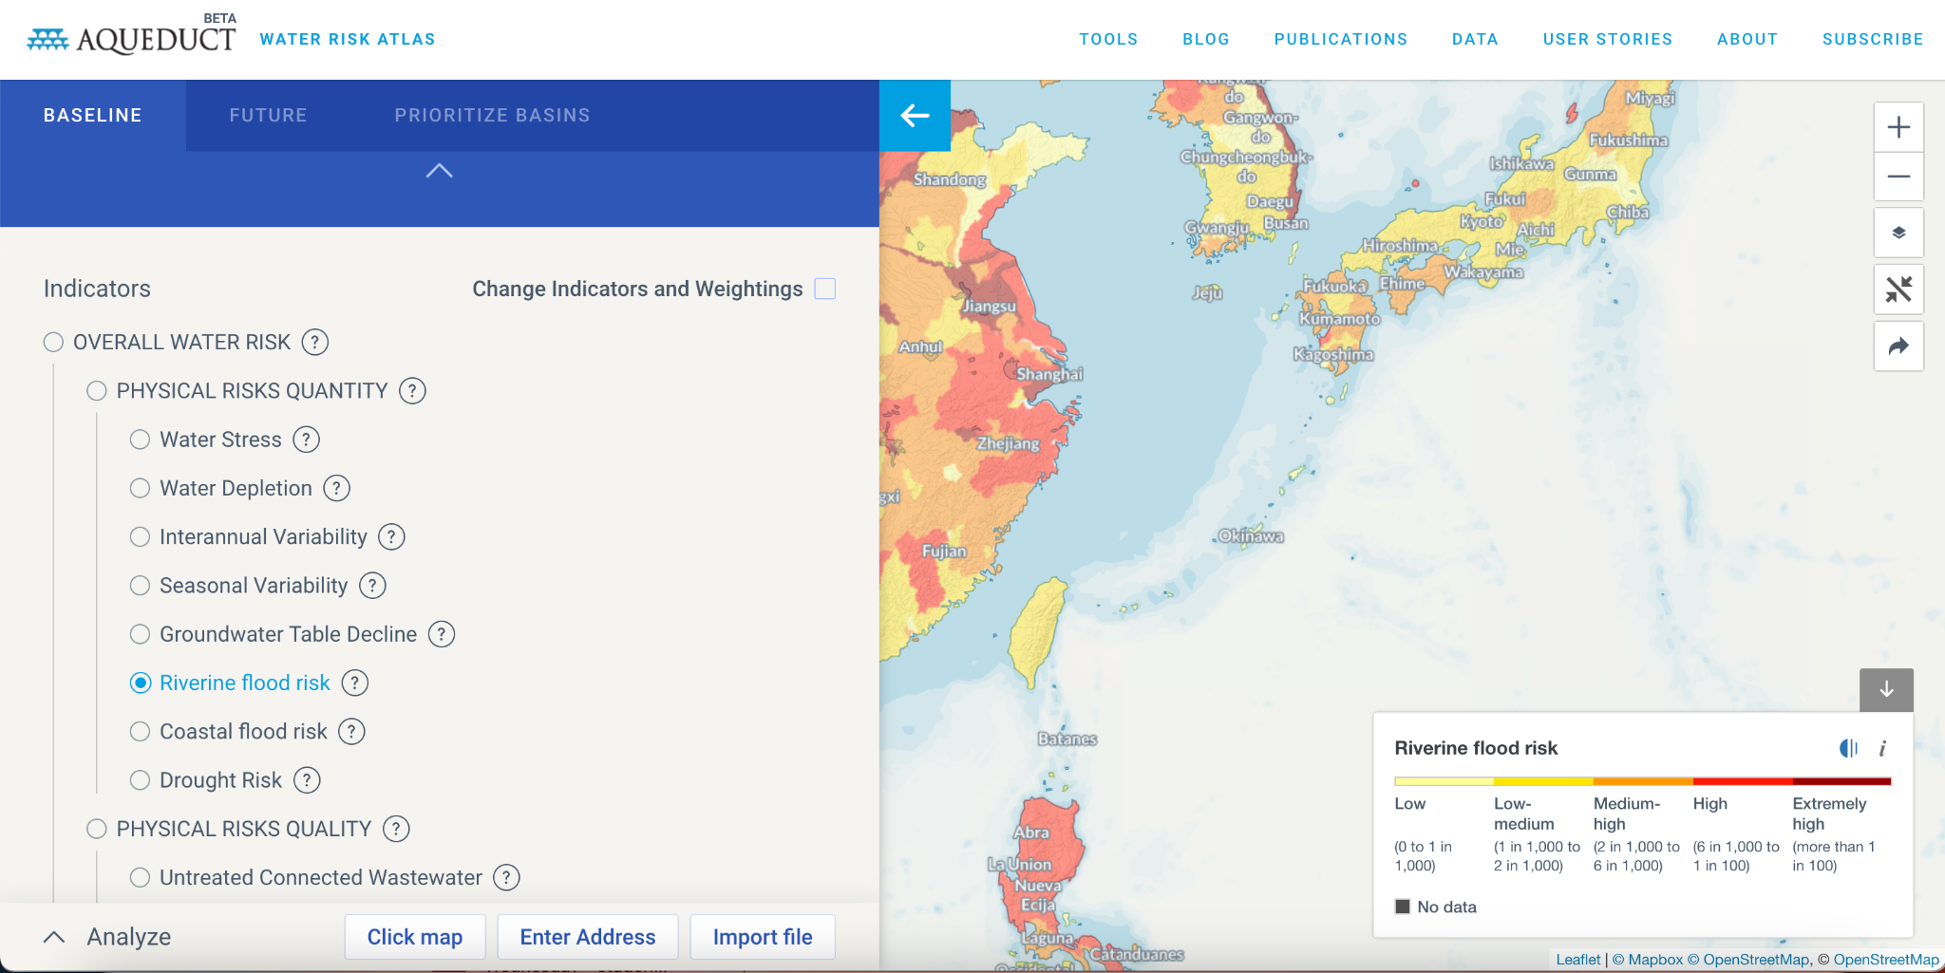

**Spatial resolution:**

**Temporal resolution:**

**Thematic resolution:**

**Application:**

### Nightlights Urbanisation: <https://www.cloudtoclassroom.org/urbanization>

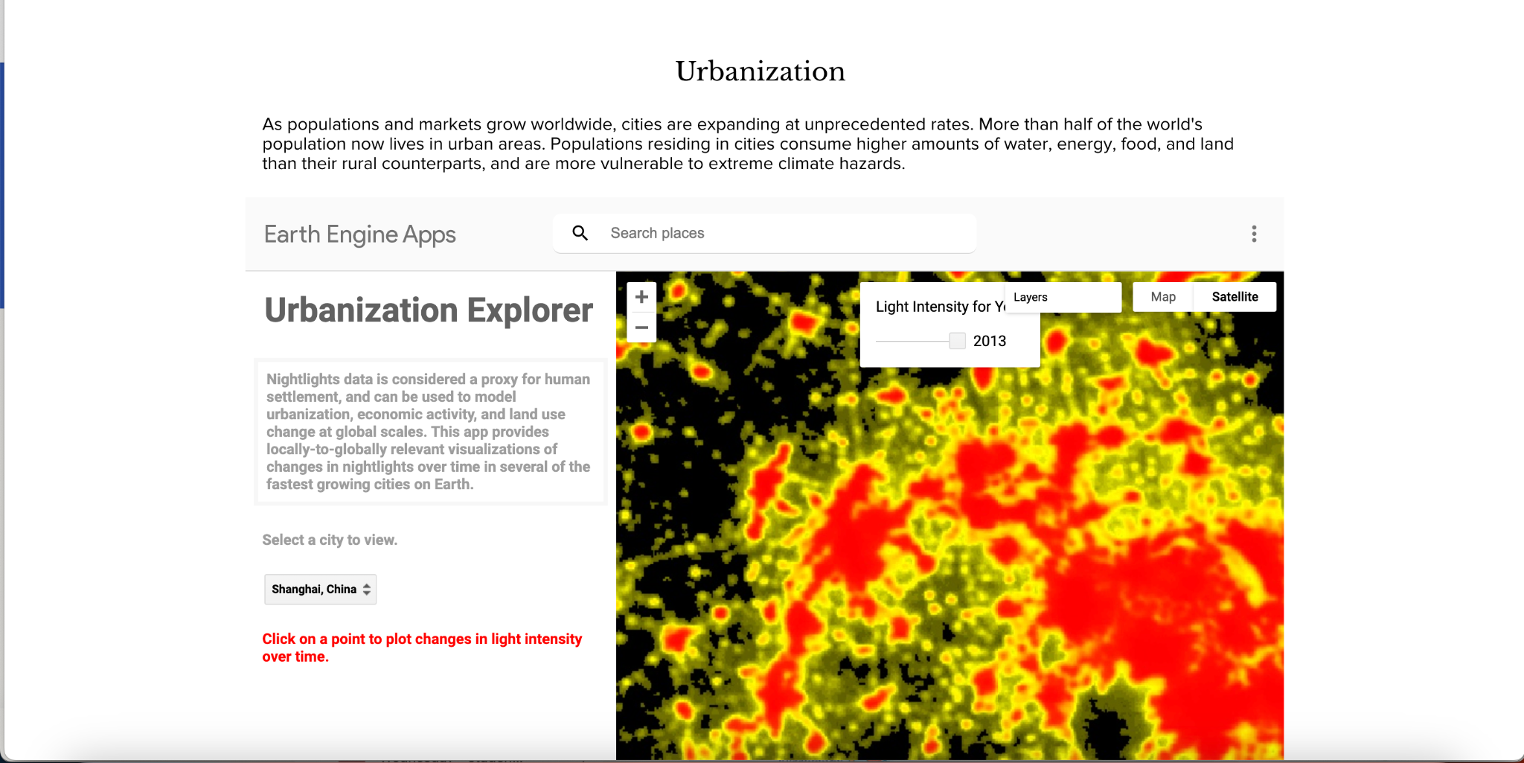

**Spatial resolution:**

**Temporal resolution:**

**Thematic resolution:**

**Application:**

### Urban Heat Island Explorer: <https://yceo.users.earthengine.app/view/uhimap>

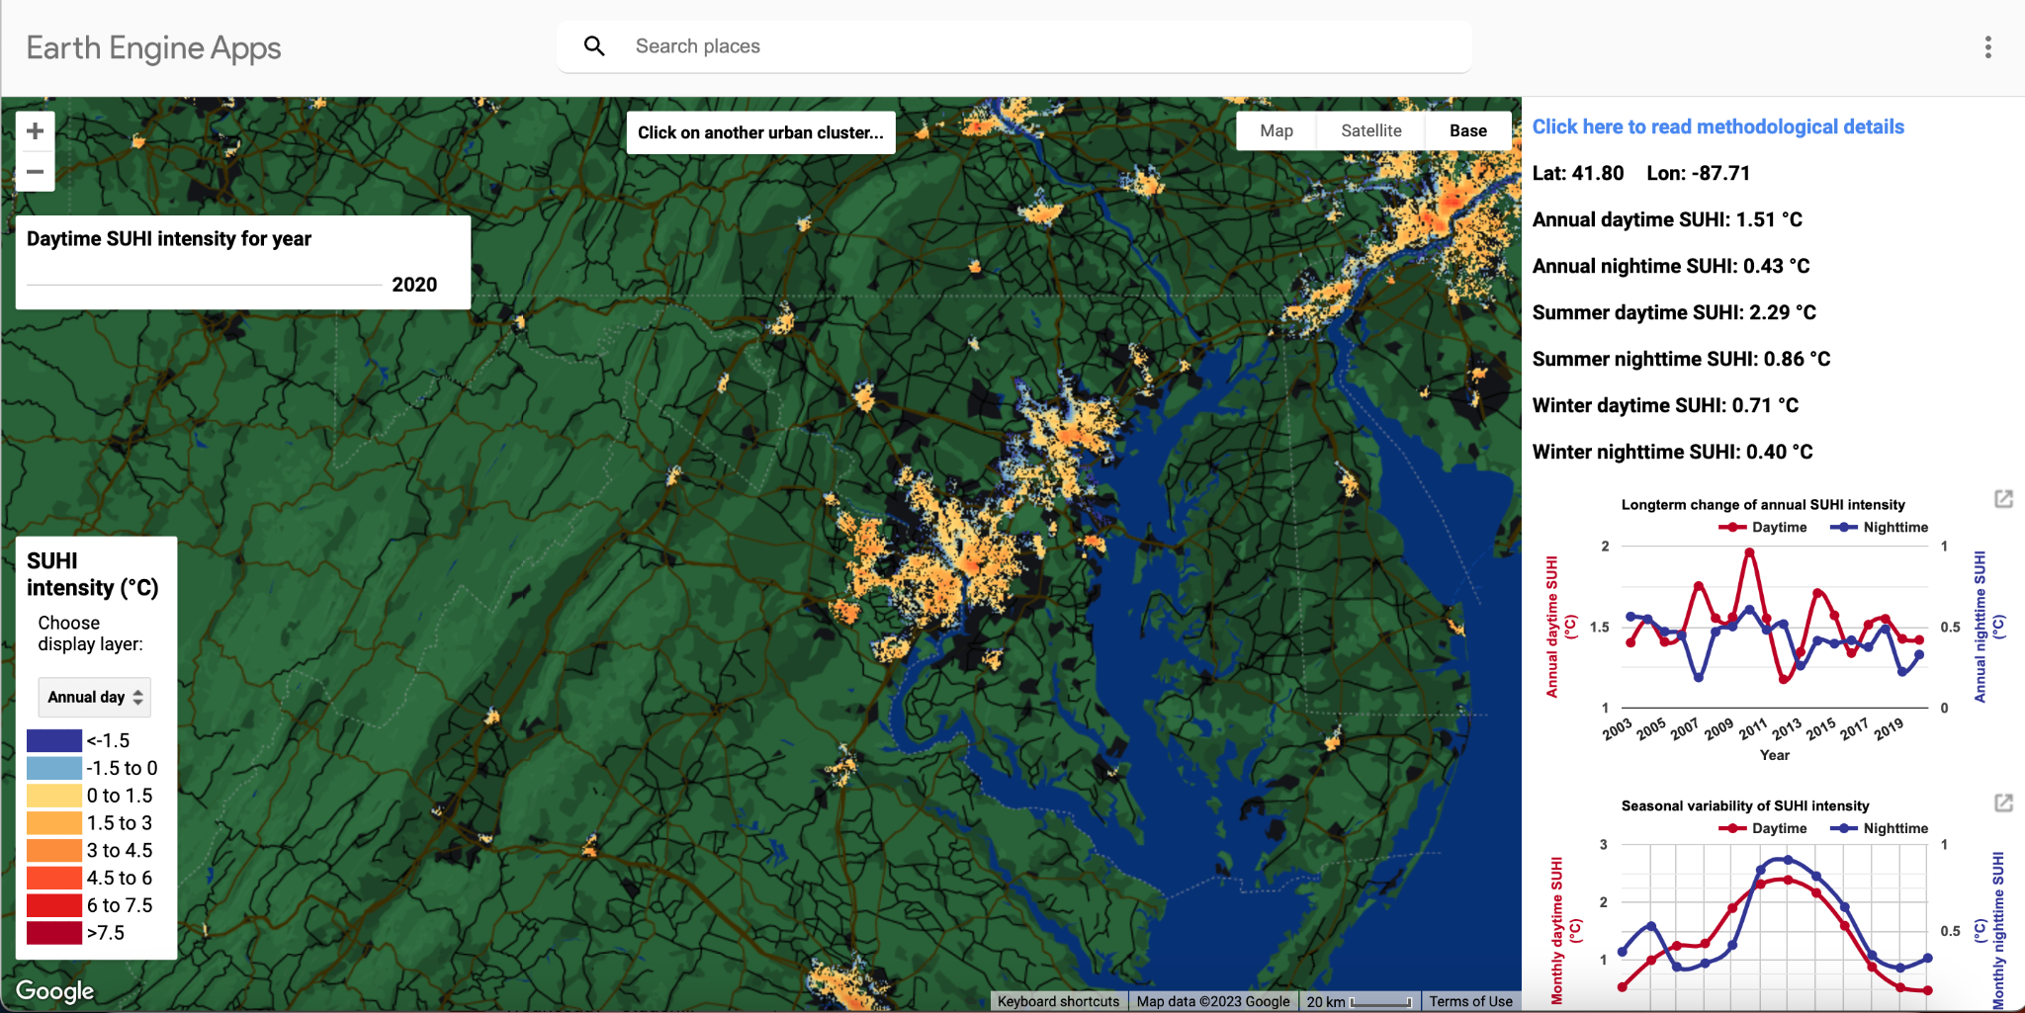

**Spatial resolution:**

**Temporal resolution:**

**Thematic resolution:**

**Application:**

### Australian Bushfires: <https://www.cloudtoclassroom.org/australian-fires>

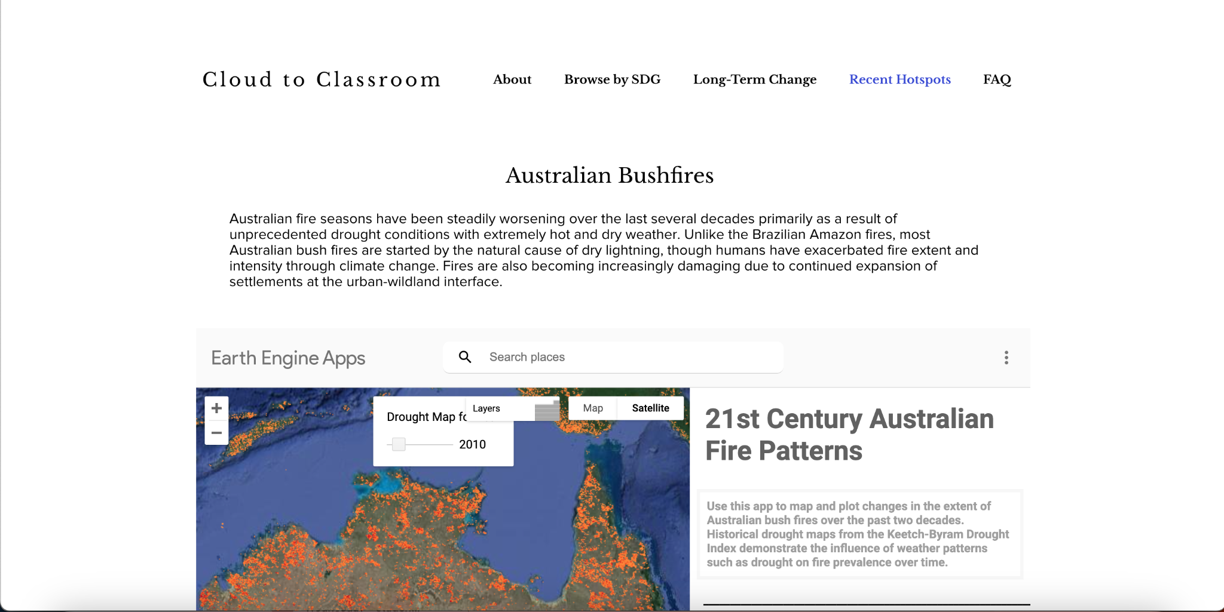

**Spatial resolution:**

**Temporal resolution:**

**Thematic resolution:**

**Application:**

### FEWSNET Acute Food Insecurity Area Classification: <https://fews.net/>

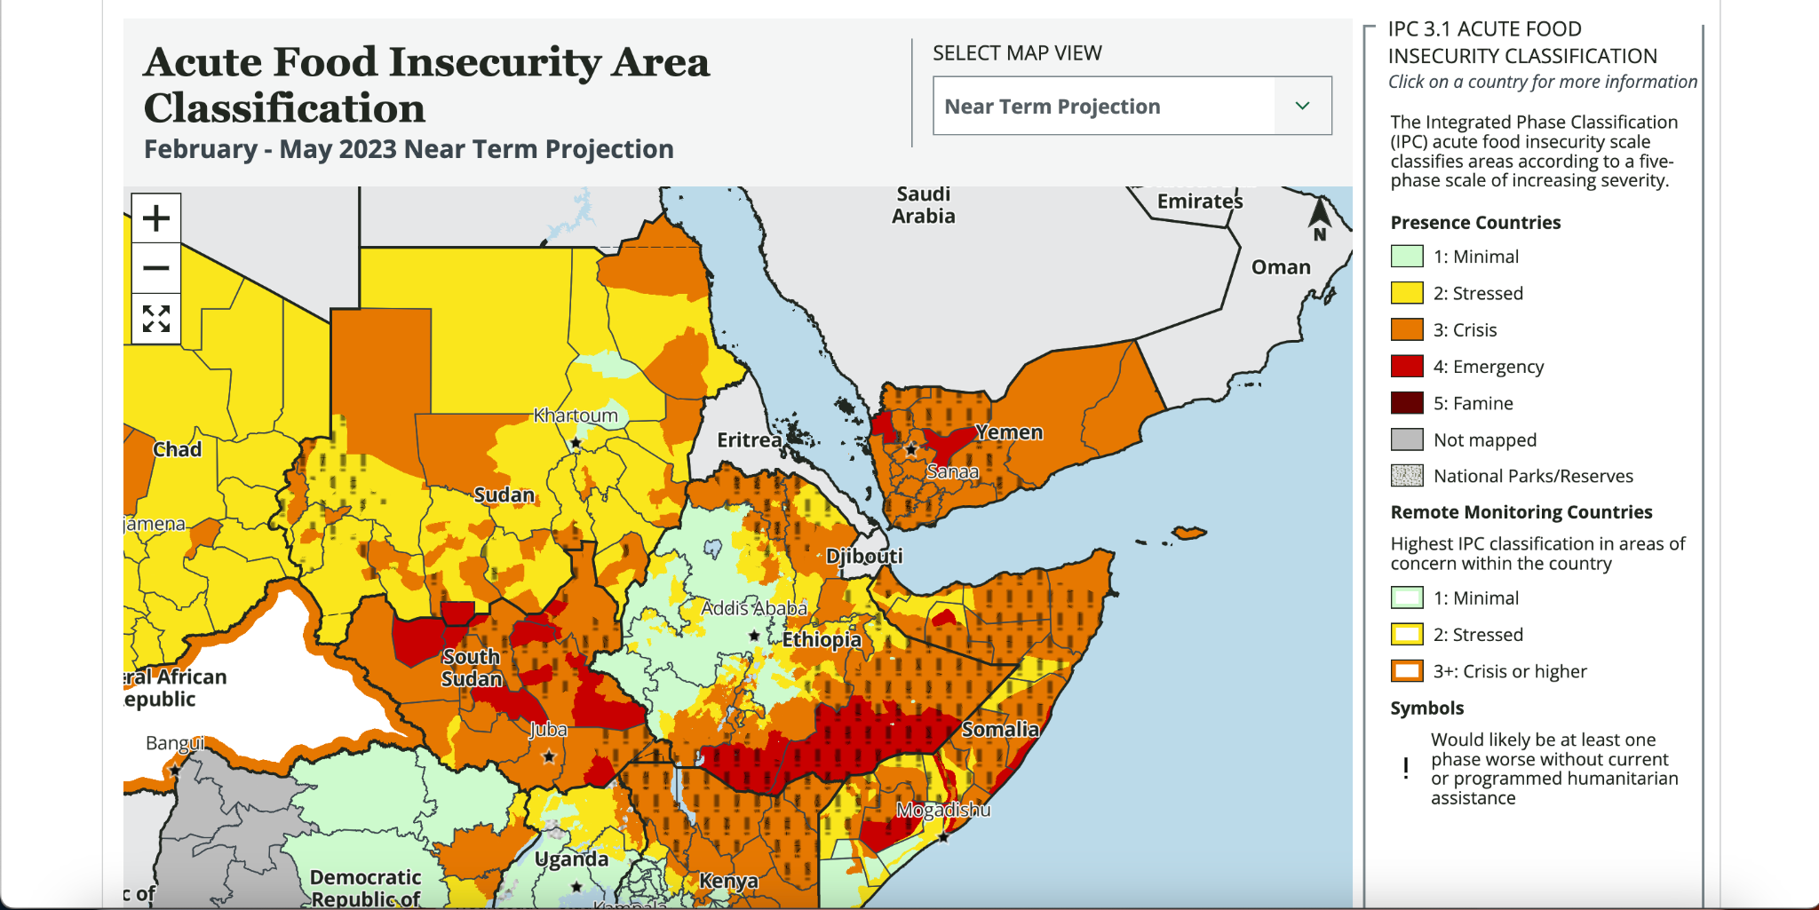

**Spatial resolution:**

**Temporal resolution:**

**Thematic resolution:**

**Application:**

# Activity 3

## Sketch a spectral signature for the following land cover classes:

* Buildings
* Grass
* Trees
* Roads
* Bare earth
* Water

Feel free to exaggerate differences in reflectance across different colours to emphasise the distinct spectral signatures and reflectance properties of different land cover classes. Also add notes that describe the different reflectance patterns demonstrated by your spectral signature charts.

**Trees**

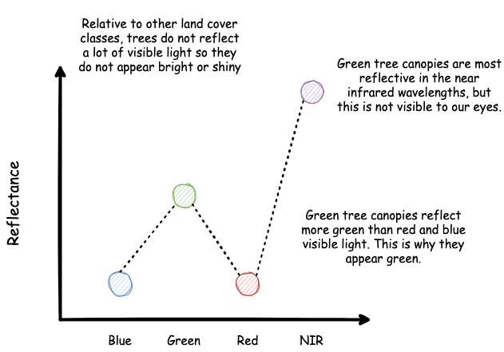

**Grass**

**Buildings**

**Roads**

**Bare Earth**

**Water**

# Activity 4

## Design a workflow to detect damaged buildings following Tropical Cyclone Seroja using satellite images.

Use the following Google Earth Engine apps to visualise before Tropical Cyclone Seroja and after Tropical Cyclone Seroja images of Kalbarri to explore how damaged buildings are represented in satellite images.

Sentinel-2: <https://jmad1v07.users.earthengine.app/view/tc-seroja-s2-bands-split-screen>

Planet: <https://jmad1v07.users.earthengine.app/view/tc-seroja-planet-bands-split-screen>

Use the following Google Earth Engine apps to visualise the spectral reflectance profile of image pixels before and after Tropical Cyclone Seroja impacted Kalbarri. Use the high resolution basemap image from Nearmap to identify damaged locations and explore how the reflectance has changed at these locations.

Sentinel-2: <https://jmad1v07.users.earthengine.app/view/tc-seroja-s2-spectral-signatures>

Planet: <https://jmad1v07.users.earthengine.app/view/tc-seroja-planet-spectral-signatures>

*What do we hypothesise the spectral signature of a damaged building / roof to be? Use the Google Earth Engine apps to sketch and describe the spectral signature of a damaged building below.*

*What do we hypothesise the spectral signature of an undamaged building / roof to be? Use the Google Earth Engine apps to sketch and describe the spectral signature of an undamaged building below.*

*What are the characteristics of satellite images that we require for this task (spatial, temporal, and thematic / radiometric resolutions)?*

*Would Planet or Sentinel-2 data be more suited to detecting damaged buildings? Why?*

*What time-periods do we need to capture images from to detect damaged buildings?*